 | Full (Ref)  N=7,019 | Marginal  N=1,136 | Low  N=1,218 | Very Low  N=721 | Overall  (N=10,094)
 | N (%) | N (%) | N (%) | N (%) | N (%)
Sex
Male | 3509 (50) | 533 (46.9) | 569 (51.5) | 569 (46.7) | 4,954 (49.1)
Female | 3,510 (50.0) | 603 (53.1) | 649 (53.3) | 378 (52.4) | 5,140 (50.9)
Age (years) | 49 (19) | 42 (18) | 42 (17) | 42 (16) | 47 (19)
Race/Ethnicity
NH White | 3,412 (48.6) | 345 (30.4) | 318 (26.1) | 250 (34.7) | 4,325 (42.8)
NH Black | 1,441 (20.5) | 297 (26.1) | 331 (27.2) | 194 (26.9) | 2,263 (22.4)
Mexican-American | 868 (12.4) | 267 (23.5) | 294 (24.1) | 139 (19.3) | 1,568 (15.5)
Other Hispanic | 520 (7.4) | 126 (11.1) | 165 (13.5) | 95 (13.2) | 906 (9.0)
Other, incl. Multi-Racial | 778 (11.1) | 101 (8.9) | 110 (9.0) | 43 (6.0) | 1,032 (10.3)
Highest Educational Attainment
Less than 9th Grade | 1,382 (19.7) | 396 (34.9) | 504 (41.4) | 284 (39.4) | 2,566 (25.4)
High School Graduate or Equivalent | 1,730 (24.6) | 320 (28.2) | 327 (26.8) | 197 (27.3) | 2,574 (25.5)
Some College | 1,939 (27.6) | 313 (27.6) | 303 (24.9) | 210 (29.1) | 2,756 (27.4)
College or Above | 1,968 (28.0) | 107 (9.4) | 84 (6.9) | 30 (4.2) | 2,189 (21.7)
Poverty Income Ratio
Low Poverty | 993 (14.1%) | 397 (34.9%) | 528 (43.3%) | 375 (52.0%) | 2,293 (22.7%)
Near Poverty | 1,560 (22.2%) | 405 (35.7%) | 458 (37.6%) | 262 (36.3%) | 2,685 (26.6%)
Middle Income | 1,085 (15.5%) | 178 (15.7%) | 127 (10.4%) | 53 (7.4%) | 1,443 (14.3%)
Upper-Middle Income | 1,679 (23.9%) | 124 (10.9%) | 91 (7.5%) | 27 (3.7%) | 1,921 (19.0%)
High Income | 1,702 (24.2%) | 32 (2.8%) | 14 (1.1%) | 4 (0.6%) | 1,752 (17.4%)
Cycle Year
2005–2006 | 1,179 (16.8) | 154 (13.6) | 148 (12.2) | 70 (9.7) | 1,551 (15.4)
2007–2008 | 1,313 (18.7) | 175 (15.4) | 168 (13.8) | 93 (12.9) | 1,749 (17.3)
2009–2010 | 1,246 (17.8) | 197 (17.3) | 234 (19.2) | 148 (20.5) | 1,825 (18.1)
2011–2012 | 1,109 (15.8) | 195 (17.2) | 192 (15.8) | 127 (17.6) | 1,623 (16.1)
2013–2014 | 1,203 (17.1) | 199 (17.5) | 218 (17.9) | 138 (19.1) | 1,758 (17.4)
2015–2016 | 969 (13.8) | 216 (19.0) | 258 (21.2) | 145 (20.1) | 1,588 (15.7)

Table 1: Unweighted Demographic Characteristics of the Analytic Study Population
- Unweighted descriptive statistics count (frequency) and proportion (percentage) per food security category reported.

Study Population

10,094 participants were included in the final analytic study (Table 1). 50.9% of which self-reported as female. Individuals with high food security were older on average (47 years) compared to the remaining food security categories (42 years). Non-Hispanic White adults represented majority of the population (42.8%), followed by Non-Hispanic Black (22.4%) and Mexican American (15.5%). The distribution across food security categories differed by race/ethnicity. Non-Hispanic Black and Mexican American adult participants represented higher proportions of the low (27.2% and 24.1%) relative to the total population. Majority of participants in the very low food security group are Non-Hispanic White participants (34.7%).
Approximately 52.9% of participants had less than a 9th grade education or a high school degree/equivalent. Participants within the low and very low food security groups were more likely to have an educational attainment less than 9th grade (41.4% and 39.4%), in comparison to the participants with high food security (19.7%). For poverty income ratio, nearly half of participants live in a low or near poverty household, accounting for 49.3%.

Table 2: Detection Frequency and Distribution of Urinary Phenol Concentrations (ng/mL)

Urinary Metabolite | Abbreviation | %>LOD | 25th | GM | 75th
Bisphenol A | BPA | 92% | 0.69 | 1.52 | 3.10
2-Hydroxy-4-metoxybenzophenone | Benzophenone-3 | 96% | 4.71 | 21.05 | 76.71
2,4,4’-Trichloro-2’-hydroxyphenyl ether | Triclosan | 75% | 1.80 | 12.22 | 49.40
Ethyl paraben | EPB | 50% | 0.71 | 2.51 | 6.70
Methyl paraben | MPB | 99% | 13.33 | 51.21 | 192.50
Propyl paraben | PPB | 95% | 1.11 | 6.72 | 40.90
- %>LOD represents the limit of detection of phenol metabolite concentrations. Values below the detection limit are imputed as LOD $\sqrt{2}$by NHANES. The 25th and 75th percentiles are log-transformed. GM represents the geometric mean.

Detection Frequency and Distribution

Tabe 2 shows the detection frequencies and distribution of the six urinary phenol metabolites. Most of the urinary phenol metabolite concentrations were above 90% limit of detection with the exception of, ethyl paraben (50%) and Triclosan (75%). Methyl paraben had the highest geometric mean of 51.21 ng/mL, while Bisphenol A had the lowest geometric mean of 1.52 ng/mL. Marginally strong correlations of parabens were exhibited (e.g. methyl and propyl (Spearman ρ= 0.82). (Supplemental Figure 2).

Table 3: Adjusted Linear Regression: Self-Reported Food Security Status and Urinary Phenol Metabolites

Phenol Metabolite | Food Security Level | % Difference | 95% LCI 95% UCI |  | P-Value
BPA | High (Ref)
 | Marginal | 1.80 | -5.91 | 10.15 | 0.65
 | Low | 7.53 | -1.27 | 17.12 | 0.09
 | Very Low | 7.61 | -4.48 | 21.23 | 0.22
BP3 | High (Ref)
 | Marginal | -19.82 | -31.68 | -5.91 | 0.01
 | Low | -17.40 | -29.05 | -3.84 | 0.01
 | Very Low | -19.55 | -35.27 | -0.02 | 0.05
TRS | High (Ref)
 | Marginal | -14.72 | -28.86 | 2.22 | 0.08
 | Low | -12.65 | -25.06 | 1.80 | 0.08
 | Very Low | -24.46 | -36.76 | -9.77 | 0.00
BUP | High (Ref)
 | Marginal | -14.08 | -21.33 | -6.15 | 0.00
 | Low | -12.94 | -23.29 | -1.18 | 0.03
 | Very Low | -25.49 | -34.95 | -14.66 | 0.00
$$EPB$$ | High (Ref)
 | Marginal | -10.97 | -21.90 | 1.50 | 0.08
 | Low | -5.65 | -17.98 | 8.53 | 0.41
 | Very Low | -25.96 | -35.07 | -15.57 | 0.00
$$MPB$$ | High (Ref)
 | Marginal | -16.65 | -26.78 | -5.10 | 0.01
 | Low | -14.81 | -28.35 | 1.29 | 0.07
 | Very Low | -21.53 | -35.05 | -5.18 | 0.01
$$PPB$$ | High (Ref)
 | Marginal | -16.26 | -28.75 | -1.59 | 0.03
 | Low | -15.16 | -32.01 | 5.85 | 0.14
 | Very Low | -25.08 | -40.79 | -5.20 | 0.02
- Values are adjusted percent differences in urinary phenol metabolite concentrations (ng/mL) compared to the High Food Secure category (reference group) based on multivariable linear regression models. adjusted for age, gender, education, cycle year, race/ethnicity, poverty: income ratio and creatinine.
- 95% LCI= 95% lower confidence interval; 95% UCI= 95% upper confidence interval.
- Abbreviations: BPA =Bisphenol A; BP3 =Bbenzophenone-3; TRS = 2,4,4’-Trichloro-2’-hydroxyphenyl ether; BUP = butyl paraben; EPB = ethyl paraben; MPB = methyl paraben; PPB = propyl paraben.

Adjusted Linear Regression
In creatinine adjusted models, several phenols including BP3, TRS, and one paraben, PPB exhibited revealed positive percent differences associated with very low food security (e.g. for BP3: 10.42%; TRS: 27.84%; and PPB; 20.60%, Supplemental Table 1).
We assessed the association between urinary phenol metabolite concentrations and food security, reporting adjusted percent differences (% difference) and 95% confidence intervals (95% CIs). In fully adjusted analysis, food security was negatively associated with most urinary phenols such that decreasing food security was associated with lower metabolite levels. For BP3, all estimates for food security levels were well below the high-food security reference and fairly similar, indicating substantially lower concentrations among marginal (-19.82%, [95% CI: -31.68%, 5.91%]), low (-17.40%, [95% CI: -29.05%, -3.84%]), very low (-19.55%, [95% CI: 35.27%, 0.02%]) food security participants. For other phenols where negative differences were observed, very low food security consistently showed the largest percent differences. Specifically, when compared to individuals with high food security, very low food insecure individuals had significantly lower levels of Triclosan (-24.46%, [95% CI: -36.76%, -9.77%]), as well as ethyl (-25.96%, [95% CI: -35.07%, -15.57%] , methyl (-21.53%, [95% CI: -35.05%, -5.18%], and propyl paraben (-25.08%, [95% CI: -40.79%, -5.20%]. Marginal food security was also associated with lower concentrations of several parabens and reached statistical significance in some, but not all, models, while estimates for low food security were generally intermediate between marginal and very low (Figure 1 Supplemental Table 3). In contrast, BPA was the only urinary phenol with positive % differences, suggesting higher concentrations with decreasing food seurity; however, all CIs contained the null. (Figure 1, Supplemental Table 3).

Figure 1: Household Food Security Associations with Urinary Phenol Concentrations
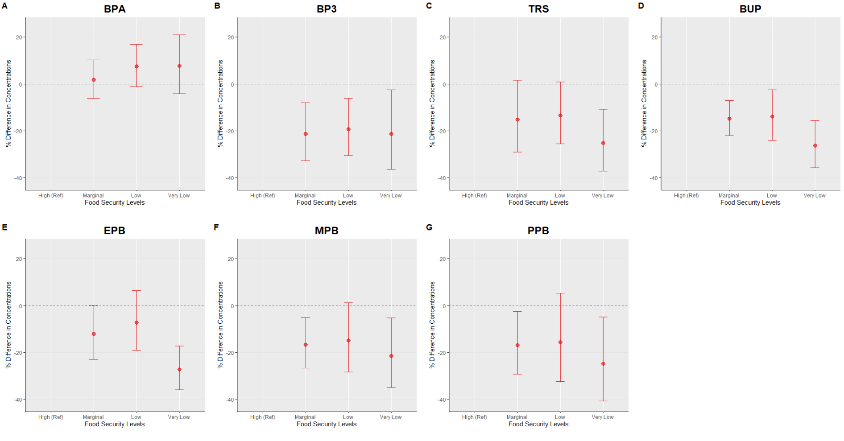
- Panels A–G represent adjusted percent differences in urinary phenol metabolite concentrations. Reference is High Food Secure. Circles represent estimated percent differences; bars represent 95% confidence intervals. All models are adjusted for age, sex education, race/ethnicity, poverty-income ratio, cycle year, and creatinine.

Figure 2: Strata Specific Adjusted Linear Regression Plot: Self-Reported Food Security Status and Urinary Phenol Metabolites with Sex Interaction

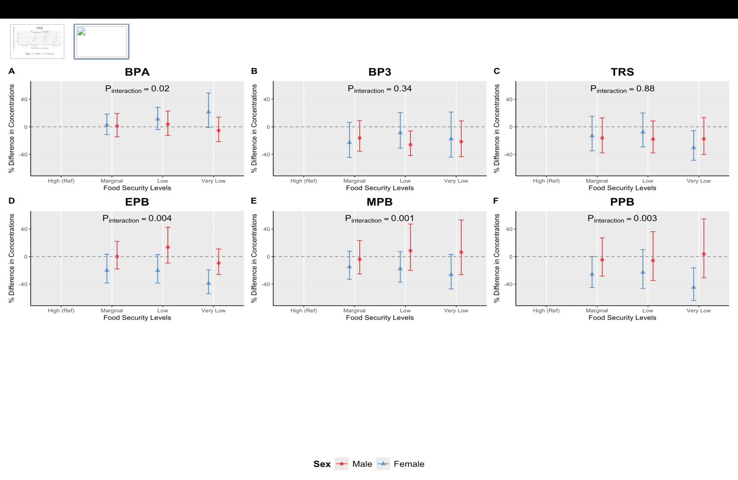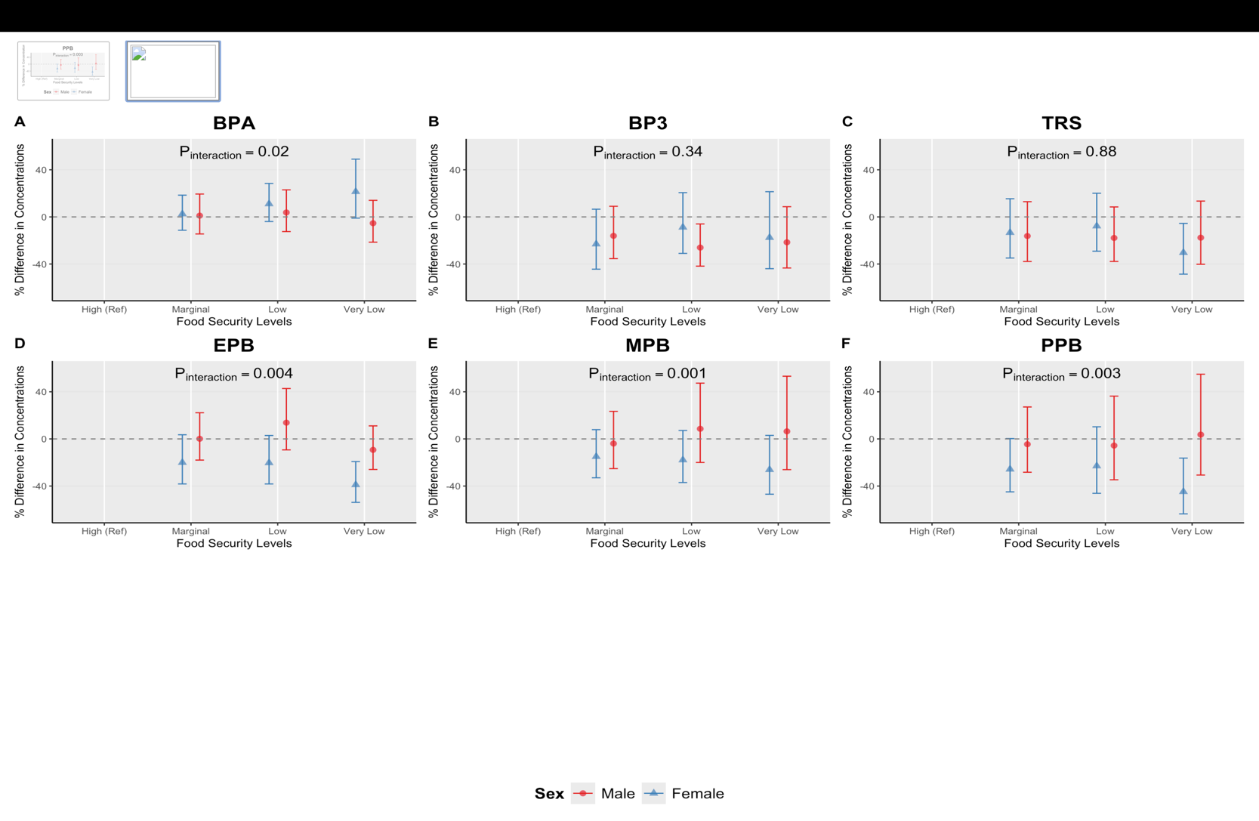

- Sex stratified adjusted percent differences (95% confidence intervals) in urinary phenol metabolite
- Concentrations across food security levels, estmated from multivariable linear regression models adjusted for age, race and ethnicity, education, survey cycle, poverty:income ratio and creatinine. High Food Secure is the reference group.
- P_{interaction} values are reported from food security*sex interaction models, where food security is modeled as continuous variable.

Effect Measure Modification by Sex
Next, we assessed potential effect measure modification by sex. There was evidence of interaction for BPA (p_{interaction}=0.02), and all parabens (ethyl (p_{interaction}<0.01), methyl (p_{interaction} <0.01), propyl (p_{interaction}<0.01). In stratum specific models, we estimated marginal means and reported them as percent differences. Among females, lower food security categories were generally associated with lower levels of ethyl paraben concentrations (marginal: -20.04%, [95% CI: 38.24%, 3.51%], low food secure females (20.29%%: 95% CI: -38.25%, 2.89%), and very low food secure females (-38.94%: 95% CI: -53.86%, -19.21%). Similar trends were observed for methyl paraben (marginal: (-14.99%; 95% CI:-33.01%, 7.87%; low: -17.85%; 95% CI: -37.03%, 7.18%; very low: -26.10%; 95 CI: -46.97%, 2.98%), and propyl paraben (marginal: (-25.71%; 95% CI:-44.96%, 0.27%%; low: -22.96%; 95% CI: -46.20%, 10.31%; very low: -44.82%; 95 CI: -63.63%, 16.28%). Parabens compared with high food secure females with the largest reductions typically observed among low and very low food secure females. In contrast, among males, higher paraben levels relative to the high food security reference were observed at low food security for ethyl paraben (13.78%) and methyl paraben (8.59%). At very low food security, male estimates were modestly positive for methyl 6.41%; 95% CI: -26.10%, 53.22%), and propyl paraben very low: 3.64%; 95% CI: -30.68%, 54.94%) (Figure 2, Supplemental Table 2).
For BPA (pinteraction= 0.02), both females and males exhibited positive differences across decreasing food security levels, although the association appeared to be slightly stronger among females. Based on strata specific predicted marginal means, females experiencing low and very low food security had higher BPA concentrations compared with females with high food security (low: 11.08%; 95% CI: -3.9%, 28.41%; very low: 21.45%; 95% CI: -1.04%, 49.05%). Among males, those experiencing very low food security had a modest negative percent difference compared to males experiencing high food security (-5.35%; 95% CI: -21.46%, 14.06%).

Figure 3: Strata-Specific Adjusted Linear Regression Plot: Self-Reported Food Security Status and Urinary Phenol Metabolites with Race and Ethnicity Interaction
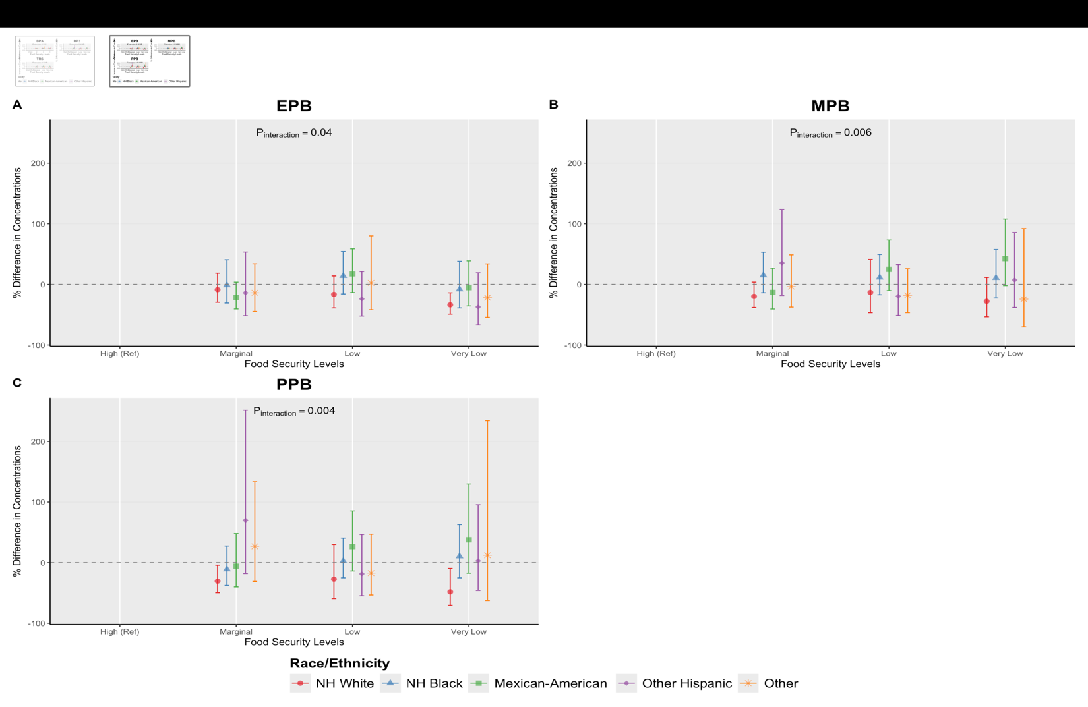

- Race stratified adjusted percent differences (95% confidence intervals) in urinary phenol metabolite concentrations across food security levels, estmated from multivariable linear regression models adjusted for age, sex, education, survey cycle, poverty:income ratio and creatinine. High Food Secure is the reference group.
- P_{interaction} values are reported from food security*race and ethnicity interaction models, where food security is modeled as continuous variable.
- NH White: Non Hispanic White; NH Black: Non-Hispanic Black

Effect Measure Modification by Race/Ethnicity
Finally, we assessed potential effect measure modification by race and ethnicity (Supplemental Tables 3-9). There was evidence of interaction all parabens, ethyl (p_{interaction}=0.04), methyl (p_{interaction}<0.01), and propyl (p_{interaction} <0.01). Within strata specific predicted marginal means, marginal means were estimated and reported as percent differences. Non-Hispanic Black adults (13.88%; CI: -15.89%, 54.18%, Figure 3, Supplemental Table 7) and Mexican American adults (17.21%; CI: -13.39%, 58.63%, Figure 3, Supplemental Table 7) experiencing low food security had marginally higher levels of ethyl paraben concentrations compared to those in these racial groups experiencing high food security. We observed similar trends in methyl paraben concentrations among Non-Hispanic Black adults (low food security: 11.32%; 95% CI: −17.07%, 49.43%) and Mexican American adults (low food security: 24.69%; 95% CI: −10.20%, 73.13%; very low food security: 42.53%; 95% CI: −2.18%, 107.69%) compared with adults who were high food secure (Figure 3; Supplemental Table 8). Higher propyl paraben concentrations were also observed among Mexican American adults experiencing low (26.54%; 95% CI: −13.62%, 85.37%) and very low food security (37.84%; 95% CI: −17.37%, 129.92%) compared with Mexican American adults who were high food secure (Figure 3; Supplemental Table 9).

Supplemental Figure 1: Flowchart for NHANES Analytic Sample (2005-2016)
18,961 NHANES participants with available Phenols, food security and/or demographic data
Removed 5,754 participants who identified as children

13,207 Adult participants with (n=9 Phenols measured across relevant cycle years 2003-2016)

Removed 2,784 participants with missing creatinine, or exposure data

10,423 Adult participants with available creatinine and USDA FSSM questionnaire data

Edit: Removed 329 participants after excluding Bisphenol F and Bisphenol S from the urinary phenol list, participants missing urinary phenol concentration data, and the 2003–2004 cycle.

10,094 included in final analytic cohort (complete cases)

- Adult participants from the 2005–2016 NHANES cycles were included if demographic, food security, urinary Phenol, and urinary creatinine data were available. Participants were excluded for missing exposure values, missing urinary creatinine or urinary Phenol concentrations, and extreme outliers.
- Abbreviations: NHANES, National Health and Nutrition Examination Survey; FSSM, Food Security Survey Module; SD, standard deviation

Supplemental Figure 2: Spearman Correlation Matrix for Log Urinary Phenol Metabolites

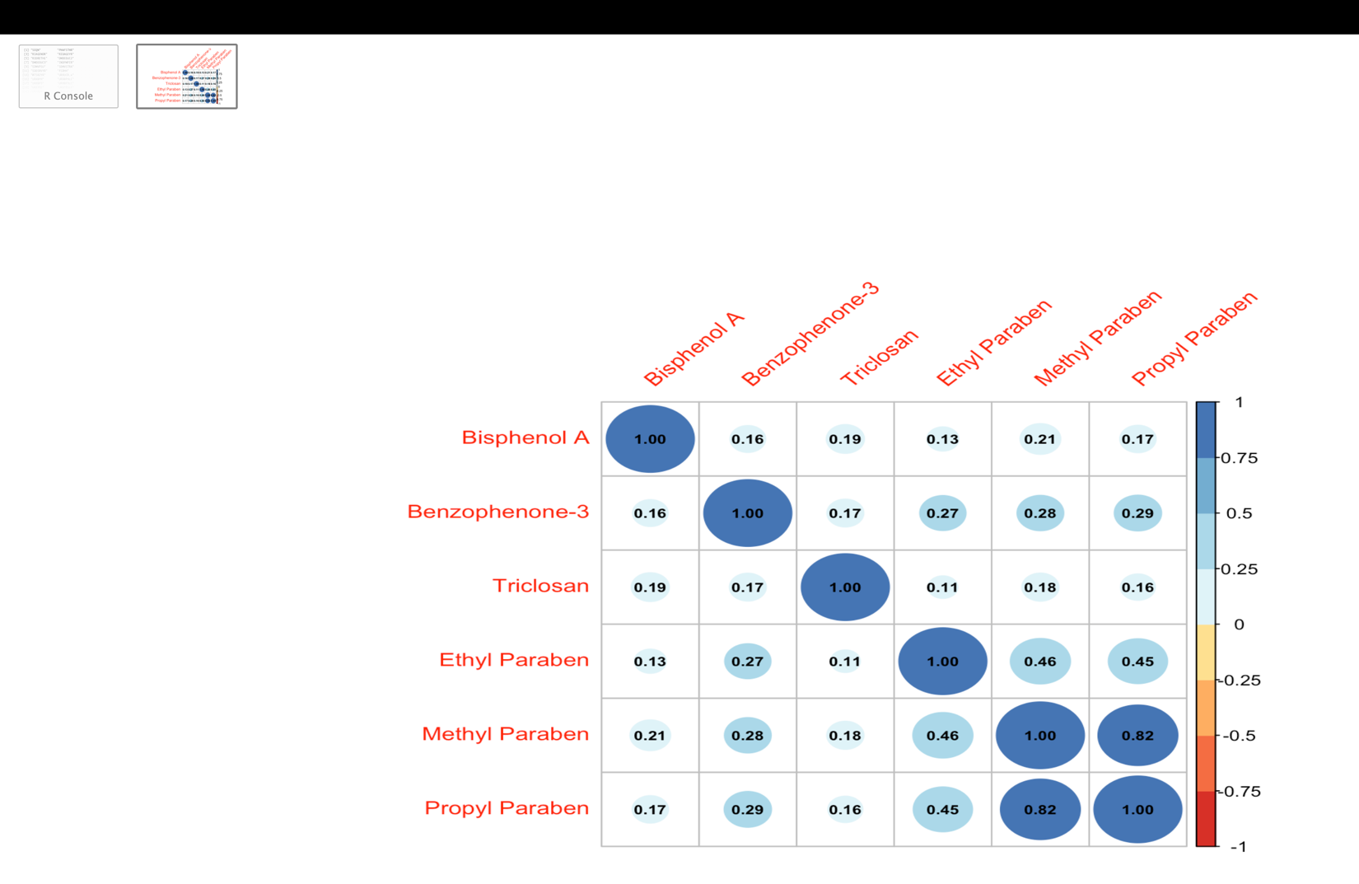

- Spearman correlation coefficients are visualized, with larger and darker circles indicating stronger positive correlations between analytes. All correlations shown are positive, suggesting co-occurrence or shared sources among the measured phenol metabolites and related compounds.

Supplemental Table 1: Creatinine Adjusted: Self-Reported Food Security Status
O  Phenol Metabolite del | Term | Food Security Level | % Difference | 95% CI |  | P-Value
BPA | Intercept (Ref)  Marginal Food Secure  Low Food Secure  Very Low Food Secure | 1
BPA |  | 2 | 1.36 | -11.93 | 16.66 | 0.85
BPA |  | 3 | -9.85 | -19.51 | 0.97 | 0.07
BPA |  | 4 | -7.25 | -20.00 | 7.53 | 0.32
BP3 | Intercept (Ref)  Marginal Food Secure  Low Food Secure  Very Low Food Secure | 1
BP3 |  | 2 | -5.08 | -12.02 | 2.41 | 0.18
BP3 |  | 3 | -2.70 | -9.25 | 4.32 | 0.44
BP3 |  | 4 | 10.42 | -0.79 | 22.89 | 0.07
TRS | Intercept (Ref)  Marginal Food Secure  Low Food Secure  Very Low Food Secure | 1
TRS |  | 2 | 23.17 | 10.38 | 37.43 | 0.00
TRS |  | 3 | 18.18 | 7.75 | 29.61 | 0.00
TRS |  | 4 | 27.84 | 15.56 | 41.41 | 0.00
EPB | Intercept (Ref)  Marginal Food Secure  Low Food Secure  Very Low Food Secure | 1
EPB |  | 2 | -9.56 | -16.70 | -1.82 | 0.02
EPB |  | 3 | -17.65 | -24.29 | -10.43 | 0.00
EPB |  | 4 | -9.17 | -19.26 | 2.18 | 0.11
MPB | Intercept (Ref)  Marginal Food Secure  Low Food Secure  Very Low Food Secure | 1
MPB |  | 2 | 1.61 | -10.47 | 15.31 | 0.80
MPB |  | 3 | -6.53 | -15.22 | 3.05 | 0.17
MPB |  | 4 | -1.07 | -12.16 | 11.42 | 0.86
PPB | Intercept (Ref)  Marginal Food Secure  Low Food Secure | 1
PPB |  | 2 | 2.86 | -3.72 | 9.89 | 0.40
PPB |  | 3 | 6.08 | 0.09 | 12.43 | 0.05
PPB |  |  | 20.60 | 9.99 | 32.23 | 0.00
PPB | Very Low Food Secure | 4
- Values are unadjusted percent differences in urinary phenol metabolite concentrations (ng/mL) compared to the reference group (High (Ref)y Food Secure) based on multivariable linear regression models.
- 95% CI= 95% confidence interval.

Supplemental Table 2: Strata Specific Adjusted Linear Regression Full Table: Self-Reported Food Security Status and Urinary Phenol Metabolites with Sex Interaction
Sex | Phenol Metabolite | Food Security Level | % Difference (Interaction) | 95% CI
Male | BPA | High (Ref)
 |  | Marginal | 1.08 | -14.46 | 19.43
 |  | Low | 3.76 | -12.46 | 22.99
 |  | Very Low | -5.35 | -21.46 | 14.06
Female |  | High (Ref)
 |  | Marginal | 2.5 | -11.32 | 18.47
 |  | Low | 11.08 | -3.9 | 28.41
 |  | Very Low | 21.45 | -1.04 | 49.05
Male | BP3 | High (Ref)
 |  | Marginal | -16.08 | -35.4 | 9.02
 |  | Low | -26.04 | -41.81 | -5.99
 |  | Very Low | -21.55 | -43.36 | 8.66
Female |  | High (Ref)
 |  | Marginal | -23.03 | -44.39 | 6.54
 |  | Low | -8.78 | -31 | 20.6
 |  | Very Low | -17.51 | -43.95 | 21.41
Male | TRS | High (Ref)
 |  | Marginal | -16.23 | -37.84 | 12.91
 |  | Low | -17.87 | -37.81 | 8.47
 |  | Very Low | -17.63 | -40.19 | 13.44
Female |  | High (Ref)
 |  | Marginal | -13.31 | -34.9 | 15.43
 |  | Low | -7.74 | -29.12 | 20.09
 |  | Very Low | -30.31 | -48.6 | -5.52
Male | BUP | High (Ref)
 |  | Marginal | -0.83 | -14.6 | 15.17
 |  | Low | 2.28 | -12.01 | 18.89
 |  | Very Low | 5.93 | -11.74 | 27.14
Female |  | High (Ref)
 |  | Marginal | -24.64 | -37.05 | -9.77
 |  | Low | -24.73 | -41.24 | -3.58
 |  | Very Low | -46.55 | -59.43 | -29.59
Male | $$EPB$$ | High (Ref)
 |  | Marginal | 0.12 | -17.97 | 22.2
 |  | Low | 13.78 | -9.33 | 42.78
 |  | Very Low | -9.31 | -25.94 | 11.07
Female |  | High (Ref)
 |  | Marginal | -20.04 | -38.24 | 3.51
 |  | Low | -20.29 | -38.25 | 2.89
 |  | Very Low | -38.94 | -53.86 | -19.21
Male | $$MPB$$ | High (Ref)
 |  | Marginal | -3.93 | -25.21 | 23.42
 |  | Low | 8.59 | -19.99 | 47.37
 |  | Very Low | 6.41 | -26.1 | 53.22
Female |  | High (Ref)
 |  | Marginal | -14.99 | -33.01 | 7.87
 |  | Low | -17.85 | -37.03 | 7.18
 |  | Very Low | -26.1 | -46.97 | 2.98
Male | $$PPB$$ | High (Ref)
 |  | Marginal | -4.53 | -28.3 | 27.13
 |  | Low | -5.65 | -34.7 | 36.34
 |  | Very Low | 3.64 | -30.68 | 54.94
Female |  | High (Ref)
 |  | Marginal | -25.71 | -44.96 | 0.27
 |  | Low | -22.96 | -46.2 | 10.31
 |  | Very Low | -44.82 | -63.63 | -16.28

Supplemental Table 3: Strata Specific Adjusted Linear Regression Full Table: Self-Reported Food Security Status and Urinary Bisphenol A Phenol Metabolites with Race and Ethnicity Interaction

Race/Ethnicity Category | Model | Food Security Contrast | % Difference | % Lower | % Upper | P-Value
NH White | BPA | High (Ref)
 |  | Marginal | 7.19 | -9.91 | 27.53 | 0.72
 |  | Low | 9.41 | -8.42 | 30.71 | 0.54
 |  | Very Low | 13.96 | -11.85 | 47.32 | 0.54
NH Black |  | High (Ref)
 |  | Marginal | -5.26 | -18.24 | 9.77 | 0.77
 |  | Low | 1.08 | -13.76 | 18.47 | 1.00
 |  | Very Low | -0.25 | -15.08 | 17.17 | 1.00
Mexican-American |  | High (Ref)
 |  | Marginal | -4.11 | -22.52 | 18.67 | 0.95
 |  | Low | 0.14 | -14.43 | 17.20 | 1.00
 |  | Very Low | -11.54 | -37.31 | 24.84 | 0.78
Other Hispanic |  | High (Ref)
 |  | Marginal | -5.61 | -28.16 | 24.01 | 0.94
 |  | Low | -5.23 | -24.30 | 18.65 | 0.92
 |  | Very Low | 2.56 | -31.39 | 53.32 | 1.00
Other |  | High (Ref)
 |  | Marginal | -6.79 | -31.10 | 26.10 | 0.93
 |  | Low | 36.95 | -16.26 | 123.98 | 0.34
 |  | Very Low | 26.41 | -18.81 | 96.82 | 0.50
- Values represent percent differences for Food Security Level × Race and Ethnicity interaction terms, showing strata-specific estimates. Within each race and ethnicity group (NH White, NH Black, Mexican American, Other Hispanic, Other, ) estimates indicate the percent difference for each food security level compared with the reference. Estimates are derived from multivariable linear regression models adjusted for age, sex, education, cycle year, poverty: income ratio and creatinine.
- NH White: Non Hispanic White; NH Black: Non-Hispanic Black
- 95% CI = 95% confidence interval

Supplemental Table 4: Strata Specific Adjusted Linear Regression Full Table: Self-Reported Food Security Status and Urinary Benzophenone-3 Phenol Metabolites with Race and Ethnicity Interaction

Race/Ethnicity Category | Model | Food Security Contrast | % Difference | % Lower | % Upper | P-Value
NH White | BP3 | High (Ref)
 |  | Marginal | -28.70 | -48.72 | -0.87 | 0.04
 |  | Low | -27.92 | -48.98 | 1.84 | 0.07
 |  | Very Low | -33.44 | -58.81 | 7.56 | 0.12
NH Black |  | High (Ref)
 |  | Marginal | -15.93 | -41.65 | 21.12 | 0.59
 |  | Low | -2.98 | -31.62 | 37.65 | 1.00
 |  | Very Low | 11.06 | -27.60 | 70.36 | 0.92
Mexican-American |  | High (Ref)
 |  | Marginal | -2.94 | -36.16 | 47.57 | 1.00
 |  | Low | 1.00 | -27.35 | 40.41 | 1.00
 |  | Very Low | 3.52 | -38.55 | 74.39 | 1.00
Other Hispanic |  | High (Ref)
 |  | Marginal | 45.85 | -24.66 | 182.35 | 0.44
 |  | Low | 2.52 | -37.93 | 69.31 | 1.00
 |  | Very Low | -9.51 | -53.73 | 76.98 | 0.98
Other |  | High (Ref)
 |  | Marginal | -33.54 | -59.54 | 9.16 | 0.14
 |  | Low | -21.54 | -54.22 | 34.48 | 0.64
 |  | Very Low | -5.03 | -56.58 | 107.74 | 1.00
- Values represent percent differences for Food Security Level × Race and Ethnicity interaction terms, showing strata-specific estimates. Within each race and ethnicity group (NH White, NH Black, Mexican American, Other Hispanic, Other) estimates indicate the percent difference for each food security level compared with the reference. Estimates are derived from multivariable linear regression models adjusted for age, sex, education, cycle year, poverty: income ratio and creatinine.
- NH White: Non Hispanic White; NH Black: Non-Hispanic Black
- 95% CI = 95% confidence interval

Supplemental Table 5: Strata Specific Adjusted Linear Regression Full Table: Self-Reported Food Security Status and Urinary Triclosan Phenol Metabolites with Race and Ethnicity Interaction

Race/Ethnicity Category | Model | Food Security Contrast | % Difference | % Lower | % Upper | P-Value
NH White | TRS | High (Ref)
 |  | Marginal | -19.32 | -44.37 | 17.01 | 0.43
 |  | Low | -21.28 | -42.74 | 8.23 | 0.20
 |  | Very Low | -27.72 | -49.16 | 2.77 | 0.08
NH Black |  | High (Ref)
 |  | Marginal | 3.33 | -31.26 | 55.33 | 1.00
 |  | Low | -4.87 | -31.91 | 32.92 | 0.98
 |  | Very Low | -8.95 | -38.66 | 35.15 | 0.92
Mexican-American |  | High (Ref)
 |  | Marginal | -10.47 | -41.78 | 37.67 | 0.90
 |  | Low | 8.20 | -34.34 | 78.30 | 0.98
 |  | Very Low | -0.75 | -47.93 | 89.18 | 1.00
Other Hispanic |  | High (Ref)
 |  | Marginal | -12.86 | -57.72 | 79.59 | 0.96
 |  | Low | 8.17 | -50.51 | 136.40 | 0.99
 |  | Very Low | -25.50 | -58.93 | 35.15 | 0.56
Other |  | High (Ref)
 |  | Marginal | -15.42 | -55.96 | 62.43 | 0.90
 |  | Low | -28.70 | -61.22 | 31.08 | 0.46
 |  | Very Low | -60.86 | -83.14 | -9.11 | 0.02
- Values represent percent differences for Food Security Level × Race and Ethnicity interaction terms, showing strata-specific estimates. Within each race and ethnicity group (NH White, NH Black, Mexican American, Other Hispanic, Other, ) estimates indicate the percent difference for each food security level compared with the reference. Estimates are derived from multivariable linear regression models adjusted for age, sex, education, cycle year, poverty: income ratio and creatinine.
- NH White: Non Hispanic White; NH Black: Non-Hispanic Black
- 95% CI = 95% confidence interval

Supplemental Table 6: Strata Specific Adjusted Linear Regression Full Table: Self-Reported Food Security Status and Urinary Butyl Paraben Metabolites with Race and Ethnicity Interaction

Race/Ethnicity Category | Model | Food Security Contrast | % Difference | % Lower | % Upper | P-Value
NH White | BUP | High (Ref)
 |  | Marginal | -23.95 | -37.16 | -7.96 | 0.00
 |  | Low | -22.47 | -37.52 | -3.79 | 0.01
 |  | Very Low | -32.29 | -48.42 | -11.10 | 0.00
NH Black |  | High (Ref)
 |  | Marginal | -5.33 | -27.71 | 23.98 | 0.95
 |  | Low | -3.31 | -30.20 | 33.93 | 0.99
 |  | Very Low | -20.74 | -40.46 | 5.51 | 0.15
Mexican-American |  | High (Ref)
 |  | Marginal | -1.61 | -31.75 | 41.85 | 1.00
 |  | Low | 25.63 | -10.42 | 76.19 | 0.29
 |  | Very Low | -1.23 | -30.43 | 40.24 | 1.00
Other Hispanic |  | High (Ref)
 |  | Marginal | 11.36 | -40.68 | 109.06 | 0.97
 |  | Low | -24.56 | -49.68 | 13.09 | 0.26
 |  | Very Low | -31.89 | -55.71 | 4.73 | 0.10
Other |  | High (Ref)
 |  | Marginal | 7.27 | -36.14 | 80.19 | 0.98
 |  | Low | -14.83 | -42.98 | 27.20 | 0.72
 |  | Very Low | 5.63 | -49.97 | 123.05 | 1.00
- Values represent percent differences for Food Security Level × Race and Ethnicity interaction terms, showing strata-specific estimates. Within each race and ethnicity group (NH White, NH Black, Mexican American, Other Hispanic, Other, ) estimates indicate the percent difference for each food security level compared with the reference. Estimates are derived from multivariable linear regression models adjusted for age, sex, education, cycle year, poverty: income ratio and creatinine.
- NH White: Non Hispanic White; NH Black: Non-Hispanic Black
- 95% CI = 95% confidence interval

Supplemental Table 7: Strata Specific Adjusted Linear Regression Full Table: Self-Reported Food Security Status and Urinary Ethyl Phenol Metabolites with Race and Ethnicity Interaction

Race/Ethnicity Category | Model | Food Security Contrast | % Difference | % Lower | % Upper | P-Value
NH White | EPB | High (Ref)
 |  | Marginal | -8.68 | -29.52 | 18.34 | 0.79
 |  | Low | -16.56 | -38.83 | 13.81 | 0.42
 |  | Very Low | -33.81 | -49.12 | -13.90 | 0.00
NH Black |  | High (Ref)
 |  | Marginal | -1.33 | -30.77 | 40.62 | 1.00
 |  | Low | 13.88 | -15.89 | 54.18 | 0.67
 |  | Very Low | -8.10 | -38.85 | 38.11 | 0.95
Mexican-American |  | High (Ref)
 |  | Marginal | -21.44 | -40.49 | 3.71 | 0.11
 |  | Low | 17.21 | -13.39 | 58.63 | 0.51
 |  | Very Low | -5.39 | -35.55 | 38.87 | 0.98
Other Hispanic |  | High (Ref)
 |  | Marginal | -13.89 | -51.65 | 53.35 | 0.90
 |  | Low | -23.94 | -52.24 | 21.12 | 0.41
 |  | Very Low | -37.32 | -67.00 | 19.05 | 0.23
Other |  | High (Ref)
 |  | Marginal | -13.86 | -44.63 | 34.02 | 0.81
 |  | Low | 2.35 | -41.84 | 80.11 | 1.00
 |  | Very Low | -21.85 | -54.36 | 33.80 | 0.62
- Values represent percent differences for Food Security Level × Race and Ethnicity interaction terms, showing strata-specific estimates. Within each race and ethnicity group (NH White, NH Black, Mexican American, Other Hispanic, Other, ) estimates indicate the percent difference for each food security level compared with the reference. Estimates are derived from multivariable linear regression models adjusted for age, sex, education, cycle year, poverty: income ratio and creatinine.
- NH White: Non Hispanic White; NH Black: Non-Hispanic Black
- 95% CI = 95% confidence interval

Supplemental Table 8: Strata Specific Adjusted Linear Regression Full Table: Self-Reported Food Security Status and Urinary Methyl Paraben Metabolites with Race and Ethnicity Interaction

Race/Ethnicity Category | Model | Food Security Contrast | % Difference | % Lower | % Upper | P-Value
NH White | MPB | High (Ref)
 |  | Marginal | -19.89 | -38.16 | 3.77 | 0.12
 |  | Low | -13.26 | -46.67 | 41.08 | 0.87
 |  | Very Low | -27.98 | -53.43 | 11.37 | 0.20
NH Black |  | High (Ref)
 |  | Marginal | 14.92 | -13.72 | 53.06 | 0.58
 |  | Low | 11.32 | -17.07 | 49.43 | 0.77
 |  | Very Low | 10.52 | -22.45 | 57.50 | 0.88
Mexican-American |  | High (Ref)
 |  | Marginal | -13.25 | -40.63 | 26.75 | 0.75
 |  | Low | 24.69 | -10.20 | 73.13 | 0.29
 |  | Very Low | 42.53 | -2.18 | 107.69 | 0.07
Other Hispanic |  | High (Ref)
 |  | Marginal | 35.32 | -18.18 | 123.81 | 0.39
 |  | Low | -19.58 | -51.35 | 32.94 | 0.66
 |  | Very Low | 7.16 | -38.14 | 85.64 | 0.99
Other |  | High (Ref)
 |  | Marginal | -3.62 | -37.52 | 48.67 | 1.00
 |  | Low | -18.07 | -46.61 | 25.72 | 0.61
 |  | Very Low | -24.38 | -70.22 | 92.06 | 0.86
- Values represent percent differences for Food Security Level × Race and Ethnicity interaction terms, showing strata-specific estimates. Within each race and ethnicity group (NH White, NH Black, Mexican American, Other Hispanic, Other, ) estimates indicate the percent difference for each food security level compared with the reference. Estimates are derived from multivariable linear regression models adjusted for age, sex, education, cycle year, poverty: income ratio and creatinine.
- NH White: Non Hispanic White; NH Black: Non-Hispanic Black
- 95% CI = 95% confidence interval

Supplemental Table 9: Strata Specific Adjusted Linear Regression Full Table: Self-Reported Food Security Status and Urinary Propyl Phenol Metabolites with Race and Ethnicity Interaction

Race/Ethnicity Category | Model | Food Security Contrast | % Difference | % Lower | % Upper | P-Value
NH White | PPB | High (Ref)
 |  | Marginal | -30.53 | -49.58 | -4.29 | 0.02
 |  | Low | -27.15 | -59.22 | 30.15 | 0.48
 |  | Very Low | -48.19 | -70.35 | -9.46 | 0.01
NH Black |  | High (Ref)
 |  | Marginal | -10.84 | -37.63 | 27.46 | 0.83
 |  | Low | 2.65 | -24.99 | 40.49 | 1.00
 |  | Very Low | 10.44 | -25.02 | 62.69 | 0.90
Mexican-American |  | High (Ref)
 |  | Marginal | -5.81 | -40.05 | 47.98 | 0.99
 |  | Low | 26.54 | -13.62 | 85.37 | 0.37
 |  | Very Low | 37.84 | -17.37 | 129.92 | 0.35
Other Hispanic |  | High (Ref)
 |  | Marginal | 69.95 | -17.84 | 251.52 | 0.23
 |  | Low | -18.43 | -54.59 | 46.52 | 0.79
 |  | Very Low | 2.87 | -45.88 | 95.53 | 1.00
Other |  | High (Ref)
 |  | Marginal | 27.03 | -30.96 | 133.74 | 0.73
 |  | Low | -17.21 | -53.35 | 46.92 | 0.82
 |  | Very Low | 12.13 | -62.41 | 234.42 | 0.99
- Values represent percent differences for Food Security Level × Race and Ethnicity interaction terms, showing strata-specific estimates. Within each race and ethnicity group (NH White, NH Black, Mexican American, Other Hispanic, Other, ) estimates indicate the percent difference for each food security level compared with the reference. Estimates are derived from multivariable linear regression models adjusted for age, sex, education, cycle year, poverty: income ratio and creatinine.
- NH White: Non Hispanic White; NH Black: Non-Hispanic Black
- 95% CI = 95% confidence interval

